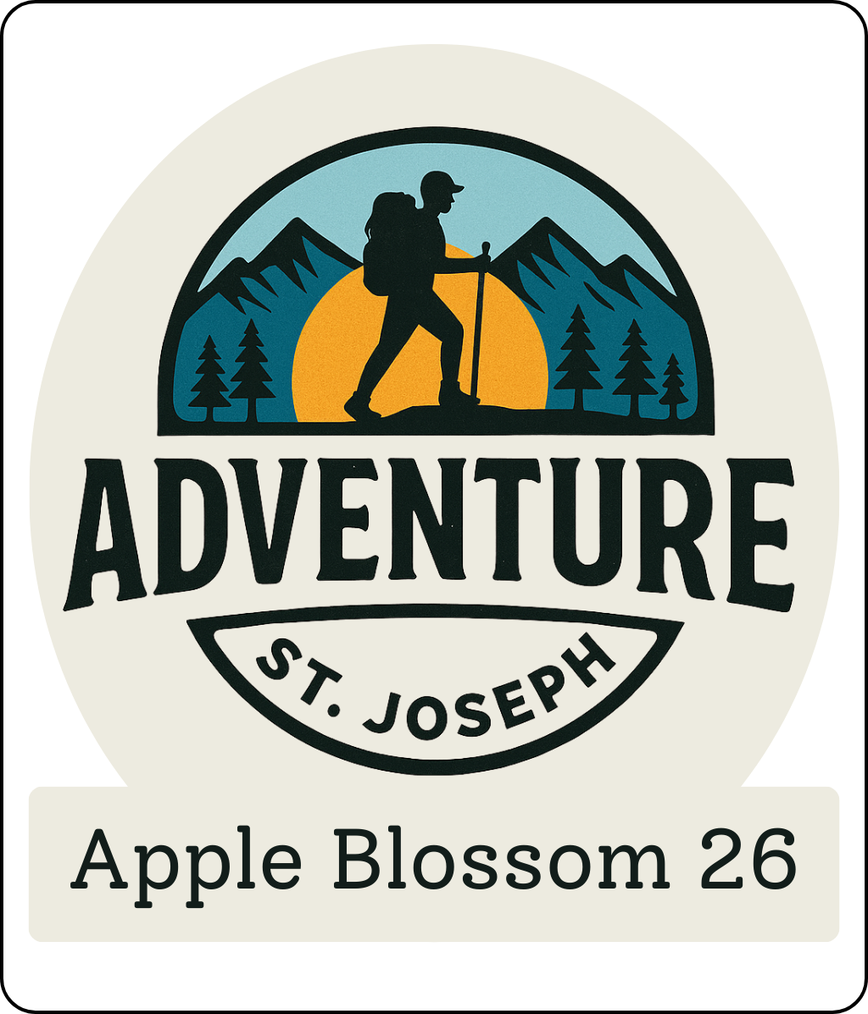

Parade Entry Guidelines

Date — Saturday • May 2, 2026 • 9:30 a.m.

APPLICATION DEADLINE: APRIL 15, 2026

Please read the entry guidelines carefully, and submit your completed application by April 15, 2026 (THIS WILL BE ENFORCED).
Applications received April 16-22, will be charged a $25 late fee; April 23-29 will have a $50 late fee.
No applications will be accepted after Wednesday, April 29 .
Notification of acceptance will be sent no later than April 28, via email. Please make sure your email address is current and legible.
NOTE: The Apple Blossom Parade rolls rain or shine. Fees are non-refundable but can be applied to 2027 entry fee in certain circumstances.

The parade will line up on a first-come basis.
NO ENTRIES WILL BE ALLOWED
ON NORTHEAST PARKWAY BEFORE 7 A.M.

Complete entry form online at

https://appleblossomparade.com/guidelines/

Theme: Adventure St. Joseph
All entries are encouraged to design their units around this theme.

Adventures in and around St. Joseph or with the America 250 celebration- also adventures in America

- All units must be decorated. See tips below for ideas or get creative and develop your own.
- Floats are strongly encouraged. In fact, we challenge you to create a float.
- Prizes will be awarded only to float entries.
- IMPORTANT: We’re proud to be Americans, and we know you are, too. So, the Apple Blossom Committee asks that all units display at least one American flag. Fly it proudly.
- The Apple Blossom Parade is a fun family event with lots of children both in entries and along the parade route. We request that your handouts reflect positive community values and avoid controversial or otherwise inappropriate issues.
- Any parade entry that causes the parade to stop (e.g. radio/television interviews, special performance groups, political entries, or those experiencing mechanical breakdown) is encouraged to immediately move to the side of the street to allow the parade to progress with ease.
- No semis are allowed in the parade.
- 2 adult spotters are encouraged to walk next to the unit and this year we are encouraging “Stay Safe Brooms” for entries to sweep the candy toward the crowd.

Tips for decorating units

CAR CHALK. Decorate the windows with window chalk, writing appropriate messages. For example, if your vehicle is pulling a parade float, you can give information about the organization involved (Girl Scout Troop 123). Also, have fun decorating around the words by drawing stars, hearts, flowers and whatever else you can think of.
STREAMERS. Tie ribbons or streamers to the car antenna. Let them hang down approximately 6 to 8 inches as you don’t want them distracting your driving. If you can find one, place an antenna topper on there as well. The same ribbon or streamers can be hung along the sides of the car. Do this by using regular clear tape, but affix it to the black trim of the window only. Tape could damage the paint.
TIN CANS. String some tin cans and tie them to the rear bumper. Use can use empty soda cans, or those from canned vegetables. Clean the cans by rinsing them with water. For the soda cans, you can tie the string to the pop top. For other cans, you can drill a small hole or tape the string to the bottom of the can. Fishing line makes a very good string for this project. The noise from the tin cans will let your presence be known from a mile away.
POSTERS. Create posters for the sides of each car. Decorate them with markers, and then adhere them to the window trim with several pieces of tape.
BALLOONS. Fill balloons will helium and attach them to the top of vehicles and high parts of floats.
FESTOONING. Festooning is a colorful garland that can be attached to edges of vehicles and floats or wrapped around parts of each.
FRINGE. Both tissue and metallic fringe can be attached to edges of vehicles and floats.
FOAMBOARD LETTERS. You can use these letters to identify your unit or group. Make sure they’re large enough to be easily read from a distance.
GRASS MATS. You can use these mats to dress up the floors and sides of trailers and other units
ENTER ONLINE at: https://appleblossomparade.com/guidelines/

Parade Entry Application

NOTE: Applications must be typed or legibly printed. If more than one organization is sponsoring, please provide information from each group

- ORGANIZATION INFORMATION
NAME
MAIN CONTACT PERSON
MAILING ADDRESS
CITY__________________________________STATE______ZIP______________
PHONE NUMBERS HOME__________________WORK________________FAX__________________
EMAIL

- BRIEF ENTRY DESCRIPTION FOR SCRIPT — GIVEN TO TV STATION
If not completed, your entry name will be only thing mentioned.
________________________________________________________________________
________________________________________________________________________
- PRIZES AND AWARDS
Grand prize for best float will be $300. Second place for best float is $150 while third place will receive $75.
Recognition awards will be given to units in the following categories: Best Float, Best Themed Float, Best Vintage Vehicle, Best Walking Unit, and Best Band.

- JUDGING (Check if unit to be judged)

___ENTRY TO BE JUDGED FOR AWARD
JUDGING WILL TAKE PLACE DURING THE PARADE & WINNERS WILL BE NOTIFIED.

- ENTRY FEE — Fees are non-refundable but can be applied to 2026 entry fee.
  - $125 for nonprofit, political candidates running for office, and other individuals.
  - $175 for all commercial, for-profit entries.
  - These fees are for a single unit (truck + trailer = 1 unit or one car = 1 unit).
  - Additional units will be charged $25each. (truck + trailer with extra car = Fee + $25)
ENTER ONLINE at: https://appleblossomparade.com/guidelines/
  - Please email AppleBlossomParade@yahoo.com with any questions regarding the online sign-ups. OR
Call 816-259-6086 and leave a message and calls will be returned.

All entries will be reviewed by the Parade Committee. Submission of entry form and fee does not guarantee acceptance.

Please read the entry guidelines carefully, and submit your completed application by April 15, 2026 (THIS WILL BE ENFORCED).
Applications received April 16-22, will be charged a $25 late fee; April 23-29 will have a $50 late fee.
No applications will be accepted after Wednesday, April 29 .
NOTE: The Apple Blossom Parade rolls rain or shine. Fees are non-refundable but can be applied to 2027 entry fee.

YOU WILL BE NOTIFIED BY EMAIL OF YOUR PARADE STATUS NO LATER THAN APRIL 30, normally will be within 1 week of your entry date

Apple Blossom Festival Association
P.O. Box 34
St. Joseph, MO 64502

HOLD HARMLESS AGREEMENT
(Must be signed by person in charge)

I (we), assume all risk of bodily injury or property damage that I/we may incur in participating in THE APPLE BLOSSOM FESTIVAL PARADE and I/we hereby, for myself, my child, my heirs, executors, and administrators do hereby, expressly, and forever waived release any and all claims against and agree to hold harmless THE APPLE BLOSSOM FESTIVAL, the event director, the City of St. Joseph, and all their respective officers, employees, agents, representatives, successors, or assigns of any kind from any and all claims which may be made for any cause whatsoever arising as a result of or in connection with the participation in the herein mentioned event. Furthermore, by signing below, I agree to abide by the guidelines included in this document.

SIGNATURE
TITLE_____________________________DATE

